
AI-Powered Legal Document Generator
Phase 06:
Project Testing

AI-generated template, not legal advice; have a lawyer review.

Table of Contents
1. Test Strategy and Environment 2
2. Automated Test Results 2
3. UI Checks on the Running Application 3
4. Requirement Traceability 4
5. Bugs Found and Fixed 4
6. Conclusion 4

1. Test Strategy and Environment
- Unit tests: parser, sanitiser, prompts, offline templates, exports, configuration.
- API tests: FastAPI TestClient for every route, validation rule and AI-failure type (fake Gemini client).
- Integration tests: real HTTP calls to uvicorn and Streamlit AppTest runs of frontend/app.py.
- End-to-end UI checks: Playwright drives the running app in Chromium and saves a screenshot per check.
- Environment: Debian 13, Python 3.13.14, 2 CPUs, 1.9 GB RAM, Chromium (Playwright 1.63.0).

2. Automated Test Results
Table 1: pytest results (97 passed in 12.14s)
Module | Area | Tests | Passed | Failed
tests/test_api.py | API routes, validation, fallback | 25 | 25 | 0
tests/test_config.py | Configuration and Demo mode | 14 | 14 | 0
tests/test_exports.py | TXT, DOCX and PDF exports | 9 | 9 | 0
tests/test_frontend.py | Frontend helpers, HTTP and AppTest UI | 13 | 13 | 0
tests/test_gemini_generator.py | Prompt, validation, error classes | 13 | 13 | 0
tests/test_offline_generator.py | Offline templates | 14 | 14 | 0
tests/test_parser_and_utils.py | Parser, sanitiser, preview | 9 | 9 | 0
Total |  | 97 | 97 | 0

Table 2: Coverage by package (pytest-cov)
Package | Line coverage
ai_core | 95% (747 of 786 statements, 6 files)
config.py | 95% (71 of 75 statements, 1 file)
frontend | 86% (205 of 239 statements, 4 files)
legalEaseAPI | 96% (108 of 113 statements, 3 files)
Total (statements) | 93% of 1,213 statements (82 missed)

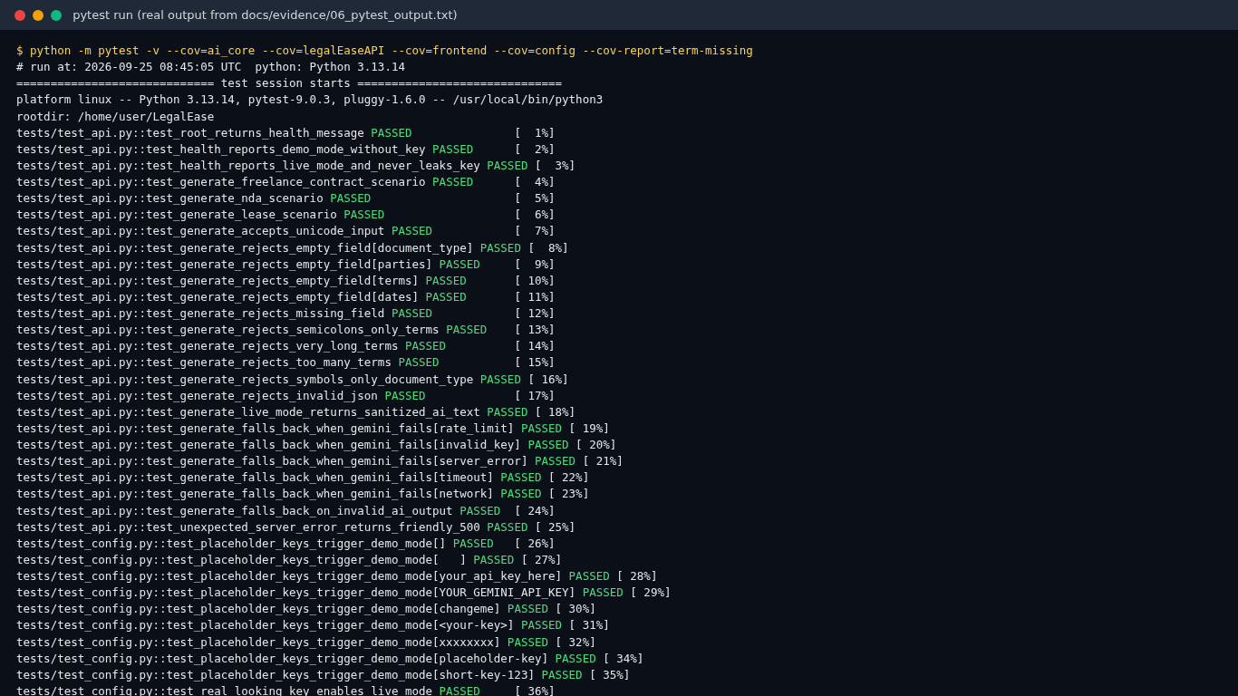 | 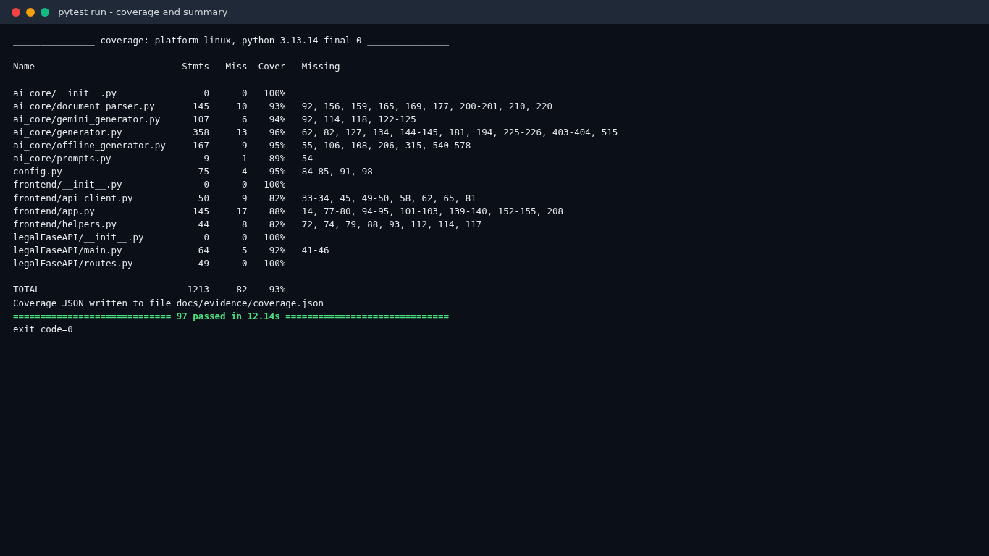
Figure 1: pytest run: tests passing | Figure 2: pytest run: coverage and summary

3. UI Checks on the Running Application
Table 3: UI checks: 17 of 17 passed
ID | Check | Actual result | Status | Screenshot
UI-01 | Home page loads with Demo mode badge and disclaimer | Badge and disclaimer found | Pass | 01_home_demo_mode.png
UI-02 | GET /health reports the resolved mode | mode = demo, model = gemini-3.8-flash | Pass | 02_api_health_endpoint.png
UI-03 | API docs list POST /generate | POST /generate listed | Pass | 03_api_swagger_docs.png
UI-04 | Scenario 1 freelance contract generated | Parties found=True, term rows=4 | Pass | 06_s1_freelance_terms_table.png
UI-05 | Scenario 2 NDA generated | Client = Disclosing Party, freelancer = Receiving Party | Pass | 08_s2_nda_generated.png
UI-06 | Scenario 3 lease generated | Address, ₹25,000 and ₹75,000 found | Pass | 11_s3_lease_rent_clauses.png
UI-07 | Edited text is saved and previewed | term rows=5 | Pass | 13_s4_edits_saved_preview.png
UI-08 | TXT download uses edited text | 5636 chars; edits found=True | Pass | 15_s4_txt_export_opened.png
UI-09 | DOCX download uses edited text and formatting | table rows=5, logos=1, pages=3 | Pass | 16_s4_docx_page1.png
UI-10 | PDF download uses edited text; header/footer on every page | pages=3, disclaimer on all=True | Pass | 18_s4_pdf_page1.png
UI-11 | Custom logo is used in the PDF export | header image size (720, 200) | Pass | 22_s5_employment_pdf_custom_logo.png
UI-12 | Empty form shows validation errors | Please fix the following before generating: | | Document type is requ | Pass | 23_edge_empty_fields.png
UI-13 | Very long terms are rejected | message shown for 5,477 characters | Pass | 24_edge_very_long_terms.png
UI-14 | Backend 422 validation message shown | Some inputs are invalid: 'document_type' must contain letters, not onl | Pass | 25_edge_invalid_input_backend_422.png
UI-15 | Backend down shows friendly error | Friendly error and offline badge shown | Pass | 27_edge_backend_down_error.png
UI-16 | AI failure falls back to offline template | Live AI generation failed: The Gemini API key was rejected (invalid ke | Pass | 29_edge_ai_failure_fallback.png
UI-17 | Mobile layout renders without horizontal scrolling | document width = 390px | Pass | 32_mobile_downloads.png

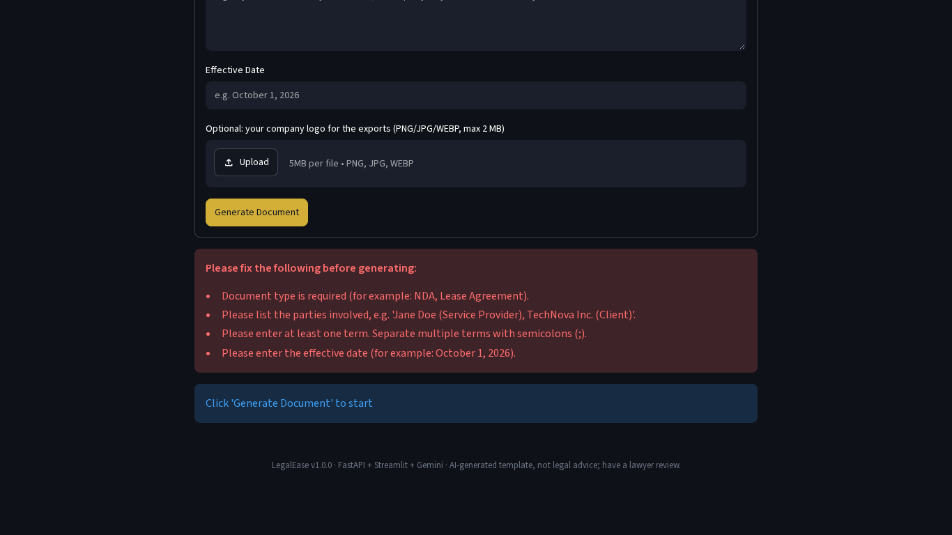 | 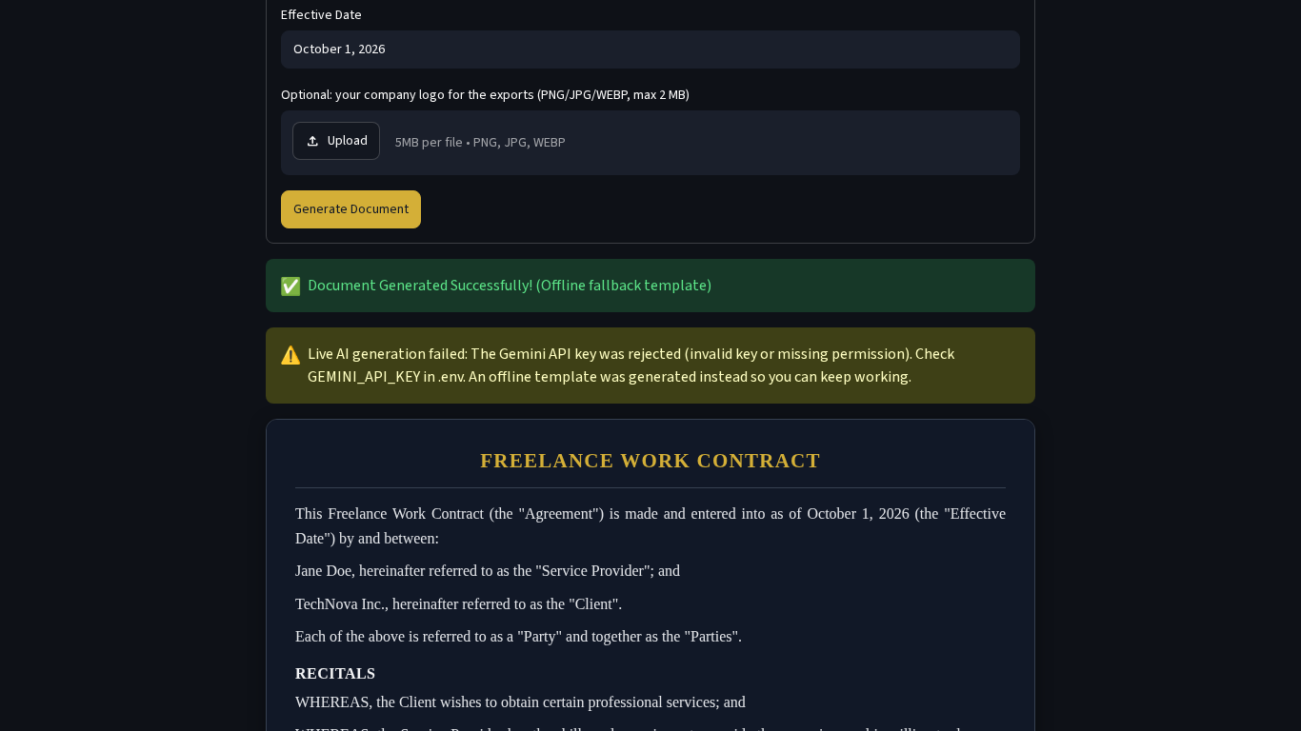
Figure 3: Empty fields: friendly validation | Figure 4: Real Gemini error: automatic fallback

4. Requirement Traceability
Table 4: Every functional requirement is covered by passing tests (details in Traceability_Matrix.xlsx)
Req. | Test cases (automated / UI) | Result
FR-01 | 7 automated / 1 UI | Covered, all passed
FR-02 | 14 automated / 3 UI | Covered, all passed
FR-03 | 13 automated / 3 UI | Covered, all passed
FR-04 | 8 automated / 1 UI | Covered, all passed
FR-05 | 23 automated / 1 UI | Covered, all passed
FR-06 | 16 automated / 1 UI | Covered, all passed
FR-07 | 3 automated / 4 UI | Covered, all passed
FR-08 | 3 automated / 1 UI | Covered, all passed
FR-09 | 8 automated / 3 UI | Covered, all passed
FR-10 | 4 automated / 2 UI | Covered, all passed
FR-11 | 4 automated / 4 UI | Covered, all passed
FR-12 | 3 automated / 2 UI | Covered, all passed
FR-13 | 3 automated / 1 UI | Covered, all passed
FR-14 | 2 automated / 1 UI | Covered, all passed
FR-15 | 4 automated / 1 UI | Covered, all passed

5. Bugs Found and Fixed
Table 5: Bug table
ID | Bug | Found by | Fix
BUG-01 | Lease template repeated the words 'Security deposit: Security deposit of ...' | Scenario 3 export review | Reworded the deposit and rent clauses; re-checked in the lease screenshots.
BUG-02 | DOCX terms table had two equal-width columns (clause number column too wide) | LibreOffice render of the DOCX | Disabled table autofit and set column widths (2.2 cm and 14 cm).
BUG-03 | DOCX footer page numbers were larger than the surrounding text | LibreOffice render of the DOCX | Each Word field part now uses its own run with the footer font size.
BUG-04 | A term row of the DOCX table could split across two pages | Long-terms export test | Added the Word 'cantSplit' property to every table row.
BUG-05 | Unit test passed raw Markdown to the output validator (test bug, not app bug) | pytest run | The test now sanitises the text first, exactly like the live code path.
BUG-06 | Result card in the testing video showed a Streamlit 'Connection error' dialog | Video frame review | The recorder now navigates to about:blank before the servers stop.

6. Conclusion
All 97 automated test cases and all 17 UI checks passed, with 93% line coverage. In total 114 test cases are listed in Test_Cases.xlsx. One path could not be verified: a successful live Gemini generation, because no real API key was available. Live-mode logic was tested with a fake client, and a real Google API error (invalid key, HTTP 400) was used to verify the fallback.

